Forest Methodist Church

February Newsletter

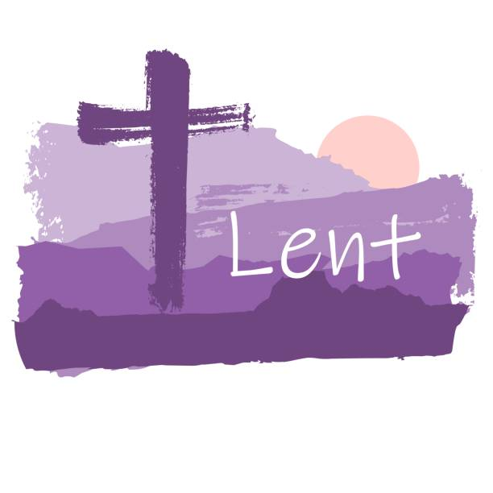

Serve Learn Share Praise
Methodist Church 
Bailiwick of Guernsey
Minister:
Rev’d Jacky Cottrell
The Manse, 2, Le Chene D’Mont, Le Chene,
Forest, GY8 0AL Tel: 234105
Email: revdcottrell@gmail.com

Hello Friends,
How is everyone doing? Well, I pray is the answer!
Is this a question, ‘How are you?’ that someone has put to you
today? I wonder how you replied. This is a greeting commonly
used. Mostly with a sincere wish to enquire about your wellbeing.
However, the response given can vary, we may even question the
person’s earnestness in asking. I guess we have all had the time
this was asked and then the asker went straight into something else without giving us time to answer. Also, we may have to be self
aware to really be able to answer and a neutral response of ‘fine’
often seems the easiest thing to do.
How we should respond appropriately is quite a question, with as
many answers as different situations and relationships we find
ourselves in.
However, to reply honestly is important. Do we all give ourselves
the time to really consider how we are? A well-being officer once
said to me as we are all made in the image of God, we are made to
love and be in healthy relationships with God, self and others. We
are made to flourish and embrace life; we are all unique and
layered, with wholeness made up of body, mind, heart and soul.
She promoted that wellbeing is not simply about feeling
‘happiness’. It incorporates a sense of purpose and satisfaction.
As Christians we have a sense of purpose in our calling from God,
whatever form that takes. It may be something that comes easily
or it may be more of a challenge.

Our covenant service reminded us of this special relationship and
promise from and with God. This time of year can catch people at a
rather low ebb and we need to keep an eye out for each other,
Feb is after all known as a time for love.
The well-being officer promoted 5 principles to follow-
1. Be active, it doesn’t have to be a sport, enjoying a gentle walk or half hour in the garden.
2. Be inquisitive – to keep learning new things, (remember our library)
3. Be present – to be aware of that moment you are in, we can be tempted to hurry about, or engrossed on screens and miss that small detail, we all need to take notice.
4. Be connected – we have many different relationships that keep us joined with others, our church family is a unique and precious one.
5. Be generous – This is second nature to most of you in varied ways, for which many worthy causes.
Think of a plant, we are to be deeply rooted in God and like the
flower we thrive when we turn to the light. Ps 92:12-15 12 ‘The
righteous will flourish like a palm tree, they will grow like a cedar
of Lebanon; planted in the house of the Lord, they will flourish in
the courts of our God. They will still bear fruit in old age, they
will stay fresh and green, proclaiming, The Lord is upright; he is
my Rock, and there is no wickedness in him.’ Jesus in John’s
gospel says how he came so we may have life and have it to the
full. Praise him for this!
So, how are you doing? Rev Jacky

MEET & EAT
We will be meeting Monday 2nd February at 7 pm.

As our group is growing, we will be meeting here at Church.
Please add your name to the list in the Welcome Area.

Also, please note, the minimum contribution is now £6. This is the first increase ever.
.

FOREST LADIES GROUP.
Ladies come and join us on
12th February at 12.30pm
LUNCH AT THE LONGFRIE
26th February, 2.00pm at the Church
GUERNSEY SEAWEED - BEN TUSTIN
Warm welcome to all Ladies
Further details from Beth
Tel: 07781 163564

PARKING FOR THE AIRPORT at Forest Methodist
We are letting out five spaces, on a first come, first served basis, at a cost of £25 per week or part thereof. These parking spaces will be at the back of the top rear car park and will be delineated.
THIS WILL BE ENTIRELY AT CAR OWNERS RISK
To reserve a space please email rosemary.willey@gmail.com and cc to carolejehan1972@gmail.com.
You will need to provide your car number, dates required and a contact telephone number. Please can you display your Christian name on your dashboard when leaving the vehicle.
It should be noted that on the rare occasions when the car park is full, I.e. funerals, access to your vehicle may be temporarily delayed.
THERE IS TO BE NO UNAUTHORISED USE OF PARKING SPACES WITHOUT FOLLOWING THE ABOVE GUIDELINES.

Bible study
at Brian's
We continue the study on 'The Chosen', all about how God has chosen us as his people. It has been televised as a series.

All are welcome at Brian's house starting at 7.30pm every 2nd and 4th Tues in the month.



Preaching & Duty Stewart Schedule
God & Marmalade is at 8.45am
Date | AM Preacher | Duty Steward
1st February | Howard Stringer | Carole
8th February | Jacky Cottrell (HC) | Sarah
15th February | Fellowship | Beth
22nd February | Jacky Cottrell | Nev

There are no Evening Services during February
Flower Rota
Date
1st February | Anne Le Marchant
8th February | Elizabeth Orr
15th February | Pam Gidney
22nd February | Debbie Hobbs

G & M Breakfast Rota
Date | Breakfast | Setting Up | Cloth Wash
1st February | Sarah | Carole/Nev | Margaret
8th February | Sandra/Ian  Jenny | Steve/Jan | Beth
15th February | Carole/Nev | David | Jenny
22nd February | Sarah | Leon | Sarah

Welcome Steward Rota

DATE | AM
1st February | Andrea
8th February | Brian
15th February | Andrea
22nd February | Jenny

With grateful thanks to all who give their time to the service of the church

Notices/articles for next month let Michelle know by Wed 25th February
Tel no: 01481 266019/07781 166019 email: mgilson_gsy@hotmail.com





Where the word Lent comes from
Lent doesn’t have anything to do with fasting or giving things up. The word ‘Lent’ has Germanic roots, referring to the lengthening of days or springtime. It has been used to signify new life and renewal.
Why is Lent 40 days?
40 is a significant number to many Christians. In the New Testament, Jesus spends 40 days in the wilderness (Mark 1:13; Matthew 4:1–11; Luke 4:1–13). Mark tells us that Jesus was tempted by Satan, while Matthew and Luke share details of Jesus going without food for 40 days.
After fasting for 40 days and 40 nights, he was hungry. The tempter came to him and said, “If you are the Son of God, tell these stones to become bread.” Jesus answered, “It is written: ‘Man shall not live on bread alone, but on every word that comes from the mouth of God.” - Matthew 4:2-4 NIV.
There are numerous other occasions in the Bible that reference the number 40. Noah waited 40 days for his ark to float. And Moses, along with his followers, travelled through the wilderness for 40 years before reaching the Promised Land.
What can you give up for Lent?
Many people choose to give up luxuries or comforts, whether it’s giving up TV, steering clear of fast food or ditching social media. Doing this is a reminder of Jesus in the desert, while also freeing up time to spend in prayer, read the Bible and reflect on God’s love, helping us grow closer to God.
Traditionally, people gave up meat, fish, eggs, wine, oil, butter and other dairy products for Lent. That’s why Shrove Tuesday, also known as Pancake Day, falls the day before Lent starts (17 February 2026). This is the last day many Christians could eat the rich and tasty foods they are giving up for Lent, and pancakes were a great way to use up their supply of eggs, milk and butter.
How to be generous during Lent
Whilst Lent is a time for remembering Jesus’ suffering, it’s also a time in which many Christians try to reflect Jesus’ teachings. In early traditions, Almsgiving was an important pillar of Lent – this means donating to people living in poverty.
“A generous person will prosper; whoever refreshes others will be refreshed.” - Proverbs 11:25 NIV.
As Christians, we’re called to give generously. In the New Testament, God gave us his only son because he loves us, and that Son died on a cross for us. It sets an example, showing us that generosity should be sacrificial.
Could you give up your daily coffee, weekly takeaway, or sweet treats for Lent? Whatever you decide to give up, you might be surprised at the money you save and how it can be used to do good.
Lent is a time to open the doors of our hearts a little wider and understand our Lord a little deeper. It’s the season to reflect on one’s own actions and words, examine one’s relationships with God and with others, and to ask God to impart to our hearts the spirit of penance.



Prayer Pages

IN YOUR PRAYERS
If you know of someone who would appreciate being on our prayer list, please ensure you have the person's permission before passing their name to Michelle.
Please pray for Win De La Mare, Karen Harrison,
Rachel Meinke, Caroline Treharne, Joyce Baudains,
Margaret Boden-Heaume, Bob Cartmell,
Rev John Luff and his wife Carole,
Howard Ellis (Sandra’s son), Debbie Hobbs,
Colleen Ogier, Debbie Dorey,
Sarah’s grandson Edward
And Philip Salmon

Bailiwick of Guernsey Churches Prayer Cycle for 2026
Feb 01 Les Adams Methodist church / Chaplaincy in Guernsey businesses
Feb 08 Parish church of St Pierre du Bois
Feb 15 Care homes & nursing homes: residents and staff
(Racial Justice Sunday)
Feb 18 ASH WEDNESDAY
Feb 22 New Life church / The Rock Community church

FACTOR 7
Please pray wherever you are: at home, work, in your car or shower, pray for
7 minutes at 7am and/or 7pm
FOCUS THIS MONTH

Please pray for our chosen charities, Shelter Box and Our Only World, as we seek to support the work they do both in the UK and around the world.

During this season of Lent, we pray for those whose journey of faith is a struggle or a wilderness at this time. Pray, too, for those who are asking questions of faith, and give thanks for those who inspire faith and discipleship in others.



Facts about St Valentine
Legend has it that St. Valentine was killed for performing illegal marriages between loving couples in ancient Rome. While imprisoned, just before his death, he is said to have signed a note to his jailer’s daughter, who he had befriended, as being from “Your Valentine.”

Saints are expected to keep busy in the afterlife. Their holy duties include interceding in earthly affairs and entertaining petitions from living souls. In this respect, St. Valentine has wide-ranging spiritual responsibilities. People call on him to watch over the lives of lovers, of course, but also for interventions regarding beekeeping and epilepsy, as well as the plague, fainting and traveling. As you might expect, he’s also the patron saint of engaged couples and happy marriages.

The flower-adorned skull of St. Valentine is on display in the Basilica of Santa Maria in Cosmedin, Rome. In the early 1800s, the excavation of a catacomb near Rome yielded skeletal remains and other relics now associated with St. Valentine. As is customary, these bits and pieces of the late saint’s body have subsequently been distributed to reliquaries around the world. You’ll find other bits of St. Valentine’s skeleton on display in the Czech Republic, Ireland, Scotland, England and France.

